

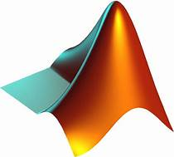

Explore

**MATLAB** is a high-level programming language designed for engineers and scientists. It allows you to express matrix and array mathematics directly, develop algorithms rapidly, and create large-scale applications. [Whether you’re a beginner or an experienced programmer, MATLAB provides a versatile environment for data analysis, modeling, and visualization1](https://www.mathworks.com/products/matlab/programming-with-matlab.html).

Here are **five free resources** to learn MATLAB:

1. [**MATLAB Onramp**](https://matlabacademy.mathworks.com/): A self-paced online course that covers the basics and gets you started quickly.
2. [**MathWorks Tutorials**](https://www.mathworks.com/support/learn-with-matlab-tutorials.html): Explore interactive courses, documentation, and code examples.
3. [**TutorialsPoint MATLAB Tutorial**](https://www.tutorialspoint.com/matlab/index.htm): Offers problem-based examples and covers both basics and advanced features.
4. [**Programming with MATLAB**](https://www.mathworks.com/products/matlab/programming-with-matlab.html): MathWorks’ official guide with features, capabilities, and support packages.
5. [**MATLAB Documentation**](https://www.mathworks.com/products/matlab.html): Comprehensive information on functions, syntax, and best practices.

Happy learning! 🚀